# Table access full scan

## Task 1: Full Scans and the High-water Mark and Block reading

**Task Results:**

|  |  |  |  |  |  |
| --- | --- | --- | --- | --- | --- |
| № | Count of Blocks | Count of Used Blocks | Count of Rows | Consistent gets | Description |
| 1 | 1664 | 1536 | 99999 | 1612 | It took us 1612 consistent gets to create & insert 9999 rows (using HWM). |
| 2 | 1664 | 0 | 0 | 1541 | HWM didn`t drop, so we still need lots of consistent gets. |
| 3 | 1664 | 1 | 1 | 1541 | While inserting 1 row HWM still didn`t dropped, so we still have lots of c.g. |
| 4 | 8 | 0 | 0 | 5 | TRUNCATE operation dropped HWM => less gets. |

# Index Scan types

## Task 2: Index Clustering factor parameter

**Task Results:**

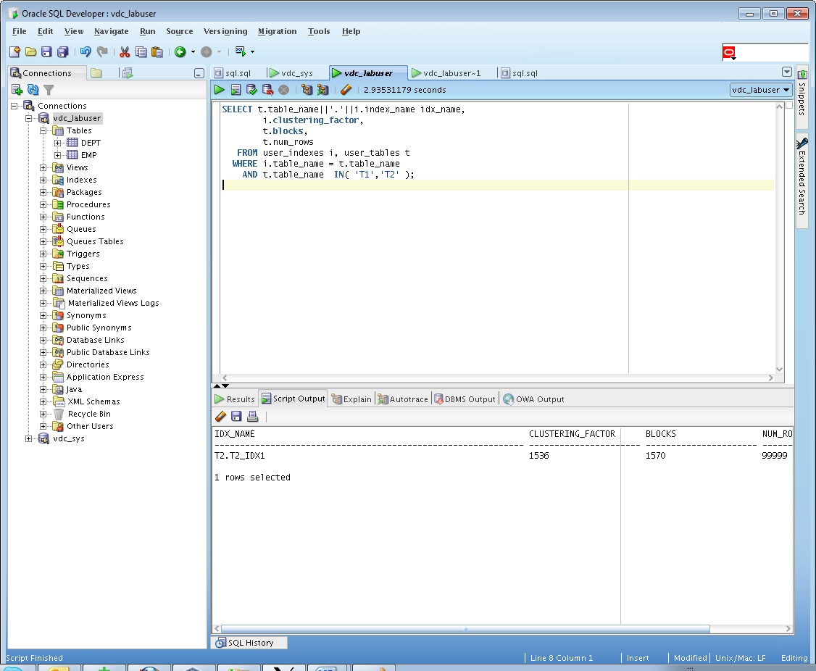

* Description of the parameter clustering factor;

Clustering factor shows us how our table is ordered in accordance with index.

If it’s value is close to block quantity – table is well-ordered, when it’s value is close to row quantity – table is ordered quite badly.

* Explanation: why for indexes t1_idx1 and t2_idx1 we have different values ;

T1 – clustering factor=row number – it means that table is badly ordered.

T2 – clustering factor=block number – table is ordered well.

## Task 3: Index Unique Scan

**Task Results:**

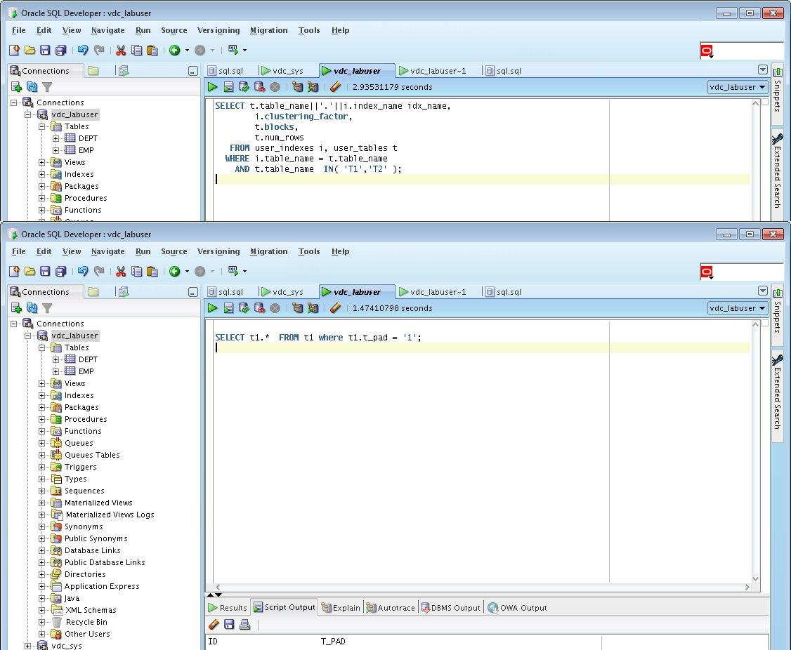

* Description of process: How oracle read block on step 2;

This method always gives us single value.

## Task 4: Index Range Scan

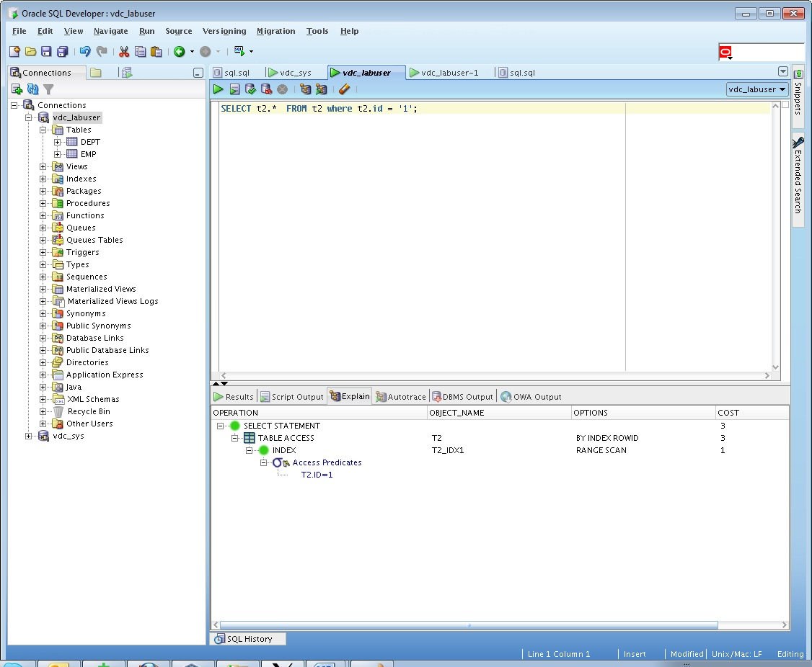

* Description of process: How oracle read block on step 1;

Using this method we can search for multiple values using index, usually used for searching values in range (limited by SQL operands).

## Task 5: Index Skip Scan

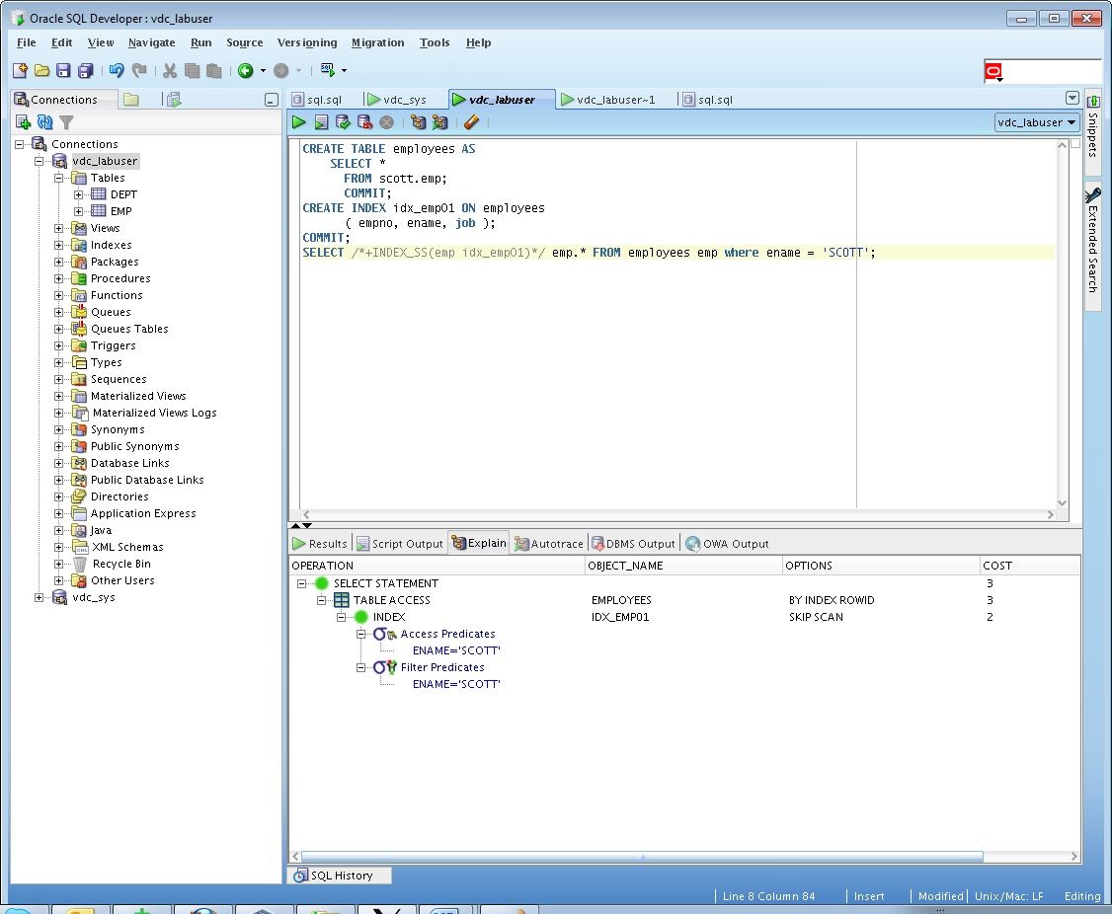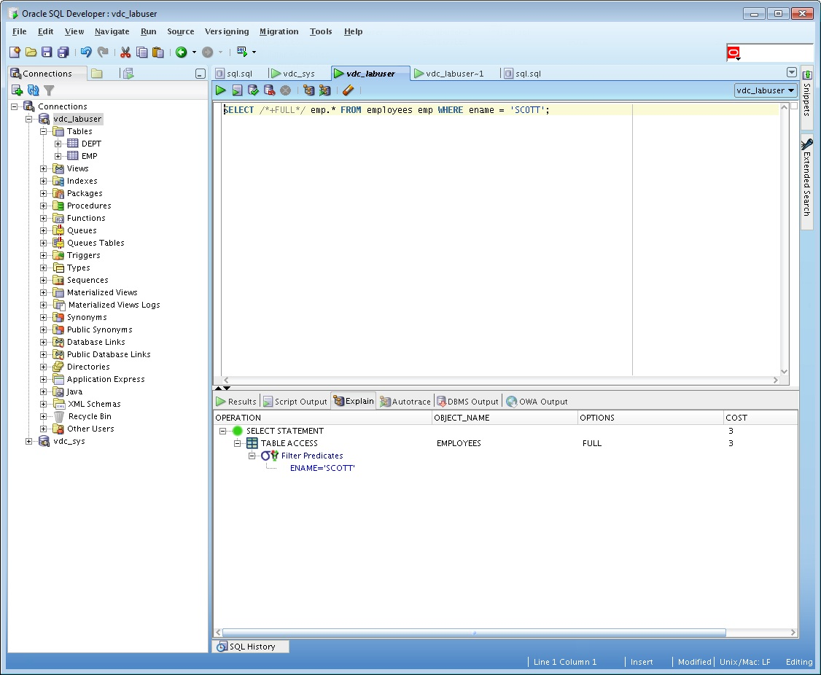

* Description of process: How oracle analyses index that was created on step 2;

Index skip scan allows us to use combined index to search data, even if in search conditions there is no leading column.

* Summary table with all result and text description of analyses this results.

|  |  |  |  |  |  |
| --- | --- | --- | --- | --- | --- |
| № | Count of Blocks | Count of Used Blocks | Count of Rows | Consistent gets | Description |
| 1 | 1664 | 1516 | 0 | 3 |  |
| 2 | 1664 | 1536 | 100 | 92 |  |
| 3 | 8 | 1 | 1 | 17 |  |
| 4 | 8 | 1 | 1 | 8 |  |